1. **Software Architecture & Requirements Specification**
   1. *SRS Document*
      1. Will Include All the things except architecture
   2. *Software Architecture*
      1. *High Level Architecture*

* *Architectural Diagrams ( Something like this )*
  + 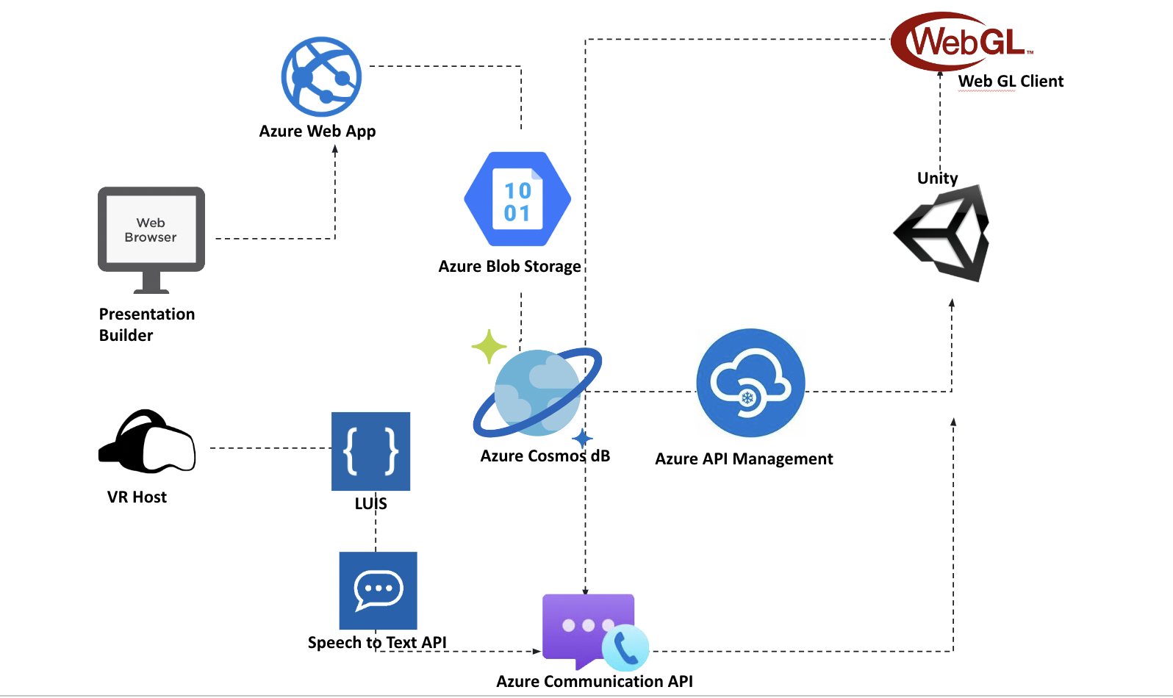
* *System Component & Interaction*
  + Different modules of a software system that work together to perform specific functions. For example database and player score data is combined to create the leaderboard systems.
* Data Flow & Communication
* Tech Stack
  + Unity
  + Firebase Realtime Database ( NoSql Cloud Database)
  + Firebase Analytics
    - Offers comprehensive app analytics to gain insights into user behavior, engagement, and app performance
  + Firebase Cloud Messaging (FCM):
    - FCM enables developers to send push notifications to users on various platforms, including Android, iOS, and the web
  + Playfab Content management
    - PlayFab provides a content management system (CMS) for managing in-game content such as levels, quests, leaderboards, and events
  + Content Management and Live Updates
    - PlayFab allows developers to make live updates to their games, delivering new content, bug fixes, or feature enhancements without requiring players to download updates.
* Scalability Considerations
  + How to scale to create more multiplayer session.
* Security & Data Privacy
  + How is user’s credentials protected ? What kind of authentication system are we using ? Two factor authentication ?
    1. *Game Level Architecture*
       - *Client Side Components*
         1. *What are the client side components which will run on the local machine only ?*
       - *Server Side Components*
         1. *What are the service side components that will run on the server explicitly ?*
       - *Networking*
         1. *What kind of networking architecture are we using ?*
         2. Client-Server Networking: Client-server networking involves a dedicated game server that acts as a central authority, managing game logic and facilitating communication between clients
       - *AI Components*
         1. *How will Judge bots , user bots be handled during the gameplay ?*
       - *Persistence & Data Storage*
       - *External Services*
         1. *What are the other external services that will be utilized in this game ? Like notification services and game analytics to see user engagement in the platform*
       - *Monetization*
         1. *What kind of payment method will the game be using ? Is it gonna be distributed directly or any institution can sign up and pay for the game ?*

1. **UI/UX Design Summary**
   1. Wireframe and Prototype( Figma Design project files )
   2. Information Architecture ( Flowchart )
   3. Visual Design
      1. Color schemes
      2. Typography
      3. icons, and imagery
      4. Visual Language
   4. Interaction Design
      1. UI Interaction
      2. 2D Animation
      3. Onboarding and Tutorials
      4. Reward Systems & Achievements
      5. Multiplayer Interactions
      6. Accessibility Features
2. **MVP**
   1. Sharable Figma Prototype